Evidence for Genomic Equivalence
The other major objection to a genetically based embryology still remained: How could nuclear genes direct development when they were the same in every cell type? The existence of this genomic equivalence was not so much proved as assumed (because every cell is the mitotic descendant of the fertilized egg), so one of the first problems of developmental genetics was to determine whether every cell of an organism indeed had the same set of genes, or genome, as every other cell.
Metaplasia
The first evidence for genomic equivalence came from embryologists studying the regeneration of excised tissues. The study of salamander eye regeneration demonstrated that even adult differentiated cells can retain their potential to produce other cell types. Therefore, the genes for these other cell types' products must still be present in the cells, though not normally expressed. In the salamander eye, removal of the neural retina promotes its regeneration from the pigmented retina, and if the lens is removed, a new lens can be formed from the cells of the dorsal iris. The regeneration of lens tissue from the iris (called Wolffian regeneration after the person who first observed it, in 1894) has been intensively studied. Yamada and his colleagues (Yamada 1966; Dumont and Yamada 1972) found that a series of events leads to the production of a new lens from the iris (Figure 4.5). The nuclei of the dorsal side of the iris begin to synthesize enormous numbers of ribosomes, their DNA replicates, and a series of mitotic divisions ensues. The pigmented iris cells then begin to dedifferentiate by throwing out their melanosomes (the pigmented granules that give the eye its color) These melanosomes are ingested by macrophages that enter the wound site. The dorsal iris cells continue to divide, forming a globe of dedifferentiated tissue in the region of the removed lens. These cells then start synthesizing the products of differentiated lens cells, the crystallin proteins. These crystallins are made in the same order as in normal lens development. Once a new lens has formed, the cells on the dorsal side of the iris cease mitosis (Mikhailov et al. 1997).
These events are not the normal route by which the vertebrate lens is formed. As mentioned in Chapter 3, the lens normally develops from a layer of head epithelial cells induced by the underlying retinal precursor cells. The formation of the lens by the differentiated cells of the iris is an example of metaplasia (or transdifferentiation), the transformation of one differentiated cell type into another (Okada 1991). The salamander iris, then, has not lost any of the genes that are used to differentiate the cells of the lens.
Amphibian cloning: The restriction of nuclear potency
The ultimate test of whether the nucleus of a differentiated cell has undergone any irreversible functional restriction is to have that nucleus generate every other type of differentiated cell in the body. If each cell's nucleus is identical to the zygote nucleus, then each cell's nucleus should be totipotent (capable of directing the entire development of the organism) when transplanted into an activated enucleated egg. Before such an experiment could be done, however, three techniques for transplanting nuclei into eggs had to be perfected: (1) a method for enucleating host eggs without destroying them; (2) a method for isolating intact donor nuclei; and (3) a method for transferring such nuclei into the host egg without damaging either the nucleus or the oocyte.
All three techniques were developed in the 1950s by Robert Briggs and Thomas King. First, they combined the enucleation of the host egg with its activation. When an oocyte from the leopard frog (Rana pipiens) is pricked with a clean glass needle, the egg undergoes all the cytological and biochemical changes associated with fertilization. The internal cytoplasmic rearrangements of fertilization occur, and the completion of meiosis takes place near the animal pole of the cell. The meiotic spindle can easily be located as it pushes away the pigment granules at the animal pole, and puncturing the oocyte at this site causes the spindle and its chromosomes to flow outside the egg (Figure 4.6). The host egg is now considered both activated (the fertilization reactions necessary to initiate development have been completed) and enucleated. The transfer of a nucleus into the egg is accomplished by disrupting a donor cell and transferring the released nucleus into the oocyte through a micropipette. Some cytoplasm accompanies the nucleus to its new home, but the ratio of donor to recipient cytoplasm is only 1:10⁵, and the donor cytoplasm does not seem to affect the outcome of the experiments. In 1952, Briggs and King, using these techniques, demonstrated that blastula cell nuclei could direct the development of complete tadpoles when transferred into the oocyte cytoplasm.
What happens when nuclei from more advanced developmental stages are transferred into activated enucleated oocytes? King and Briggs (1956) found that whereas most blastula nuclei could produce entire tadpoles, there was a dramatic decrease in the ability of nuclei from later stages to direct development to the tadpole stage (Figure 4.7). When nuclei from the somatic cells of tailbud-stage tadpoles were used as donors, normal development did not occur. However, nuclei from the germ cells of tailbud-stage tadpoles (which could give rise to a complete organism after fertilization) were capable of directing normal development in 40% of the blastulae that developed (Smith 1956). Thus, most somatic cells appeared to lose their ability to direct development as they became determined and differentiated.
Amphibian cloning: The pluripotency of somatic cells
Is it possible that some differentiatied cell nuclei differ from others in their ability to direct development? John Gurdon and his colleagues, using slightly different methods of nuclear transplantation on the frog Xenopus, obtained results suggesting that the nuclei of some differentiated cells can remain totipotent. Gurdon, too, found a progressive loss of potency with increasing developmental age, although Xenopus cells retained their potencies for a longer period than did the cells of Rana (Figure 4.8). The exceptions to this rule, however, proved very interesting. Gurdon transferred nuclei from the intestinal endoderm of feeding Xenopus tadpoles into activated enucleated eggs. These donor nuclei contained a genetic marker (one nucleolus per cell instead of the usual two) that distinguished them from host nuclei. Out of 726 nuclei transferred, only 10 (1.4%) promoted development to the feeding tadpole stage. Serial transplantation (transplanting an intestinal nucleus into an egg and, when the egg had become a blastula, transferring the nuclei of the blastula cells into several more eggs) increased the yield to 7% (Gurdon 1962). In some instances, nuclei from tadpole intestinal cells were capable of generating all the cell lineages—neurons, blood cells, nerves, and so forth—of a living tadpole. Moreover, seven of these tadpoles (from two original nuclei) metamorphosed into fertile adult frogs (Gurdon and Uehlinger 1966); these two nuclei were totipotent (Figure 4.9).
King and his colleagues criticized these experiments, pointing out that (1) not enough care was taken to make certain that primordial germ cells, which can migrate through to the gut, were not used as sources of nuclei, and (2) the intestinal epithelial cells of such a young tadpole may not qualify as a truly differentiated cell type because such cells of feeding tadpoles still contain yolk platelets (Di Berardino and King 1967;McKinnell 1978; Briggs 1979). To answer these criticisms, Gurdon and his colleagues cultured epithelial cells from adult frog foot webbing. These cells were shown to be differentiated; each of them contained a specific keratin, the characteristic protein of adult skin cells. When nuclei from these cells were transferred into activated, enucleated Xenopus oocytes, none of the first-generation transfers progressed further than the formation of the neural tube shortly after gastrulation. By serial transplantation, however, numerous tadpoles were generated (Gurdon et al. 1975). Although these tadpoles all died prior to feeding, they showed that a single differentiated cell nucleus still retained incredible potencies.
Cloning mammals
In 1997, Ian Wilmut announced that a sheep had been cloned from a somatic cell nucleus from an adult female sheep. This was the first time that an adult vertebrate had been successfully cloned from another adult. To do this, Wilmut and his colleagues 1997 took cells from the mammary gland of an adult (6-year-old) pregnant ewe and put them into culture. The culture medium was formulated to keep the nuclei in these cells at the resting stage of the cell cycle (G₀). They then obtained oocytes (the maturing egg cell) from a different strain of sheep and removed their nuclei. The fusion of the donor cell and the enucleated oocyte was accomplished by bringing the two cells together and sending electrical pulses through them. The electric pulses destabilized the cell membranes, allowing the cells to fuse together. Moreover, the same pulses that fused the cells activated the egg to begin development. The resulting embryos were eventually transferred into the uteri of pregnant sheep. Of the 434 sheep oocytes originally used in this experiment, only one survived: Dolly (Figure 4.10A). DNA analysis confirmed that the nuclei of Dolly's cells were derived from the strain of sheep from which the donor nucleus was taken (Ashworth et al. 1998; Signer et al. 1998). Thus, it appears that the nuclei of adult somatic cells can be totipotent. No genes necessary for development have been lost or mutated in a way that would make them nonfunctional.
This result has been confirmed in cows (Kato et al. 1998) and mice (Wakayama et al. 1998). In mice, somatic cell nuclei from the cumulus cells of the ovary were injected directly into enucleated oocytes. These re-nucleated oocytes were able to develop into mice at a frequency of 2.5% (Figure 4.10B,Figure 4.10C). Interestingly, nuclei from other somatic cells (such as neurons or Sertoli cells) that are similarly blocked at the G₀ stage did not generate any live mice. Cumulus cell nuclei from cows have also directed the complete development of oocytes into mature cows (Kato et al. 1998).
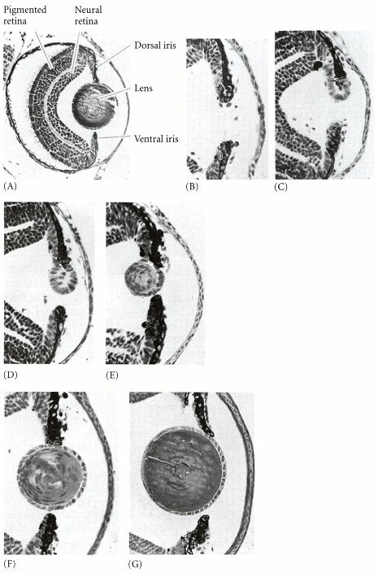
Figure 4.5. Wolffian regeneration of the salamander lens from the dorsal margin of the iris. (A) Normal eye of the larval-stage newt Notophthalmus viridescens. (B-G) Regeneration of the lens, seen on days 5, 7, 9, 16, 18, and 30, respectively. The new lens is complete at day 30. (From Reyer 1954; photographs courtesy of R. W. Reyer.)
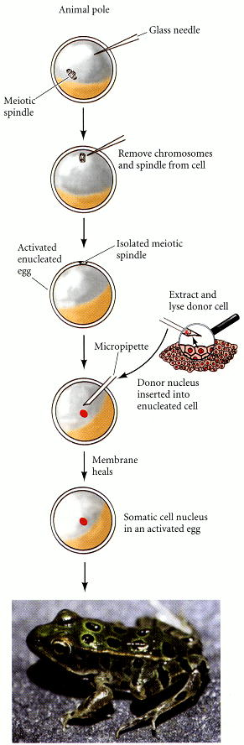
Figure 4.6. Procedure for transplanting blastula nuclei into activated enucleated Rana pipiens eggs. The relative dimensions of the meiotic spindle have been exaggerated to show the technique. “Freddy,” the handsome and mature R. pipiens in the photograph, was derived in this way by M. DiBerardino and N. Hoffner Orr. (After King 1966; photograph courtesy of M. DiBerardino.)

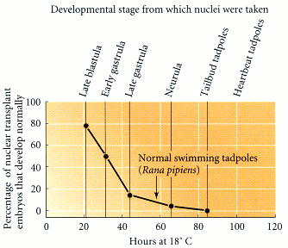
Figure 4.7. Percentage of successful nuclear transplants as a function of the developmental age of the donor nucleus. The abscissa represents the developmental stage at which a donor nucleus (from R. pipiens) was isolated and inserted into an activated enucleated oocyte. The ordinate shows the percentage of those transplants capable of producing blastulae that could then direct development to the swimming tadpole stage. (After McKinnell 1978.)

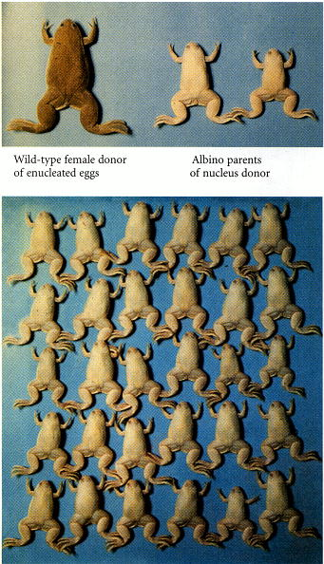
Figure 4.8. A clone of Xenopus laevis frogs. The nuclei for all the members of this clone came from a single individual—a female tailbud-stage tadpole whose parents (upper panel) were both marked by albino genes. The nuclei (containing these defective pigmentation genes) were transferred into activated enucleated eggs from a wild-type female (upper panel). The resulting frogs were all female and albino (lower panel). (Photographs courtesy of J. Gurdon.)

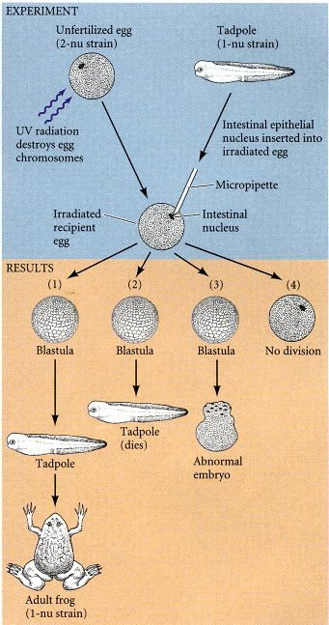
Figure 4.9. Procedure used to obtain mature frogs from the intestinal nuclei of Xenopus tadpoles. The wild-type egg (with two nucleoli per nucleus; 2-nu) is irradiated to destroy the maternal chromosomes, and an intestinal nucleus from a marked (1-nu) tadpole is inserted. In some cases, there is no cell division; in some cases, the embryo is arrested in development; but in other cases, an entire new frog, with a 1-nu genotype, is formed. (After Gurdon 1968,Gurdon 1977.)

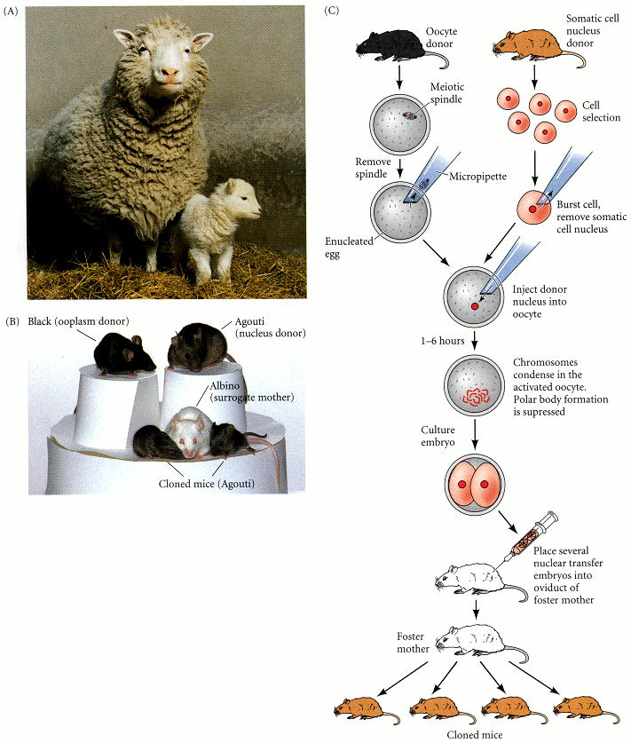
Figure 4.10. Cloned mammals, whose nuclei came from adult somatic cells. (A) Dolly, the adult sheep on the left, was derived by fusing a mammary gland cell nucleus with an enucleated oocyte, which was then implanted in a surrogate mother (of a different breed of sheep) who gave birth to Dolly. Dolly has since produced a lamb (Bonnie, at right) by normal reproduction. (B) Cloned mice and their “parents.” The upper left black mouse is the oocyte donor, while the upper right brown (agouti) mouse is the nucleus donor. The white mouse in the lower row is the mouse into whose uterus the resulting embryos were implanted. The two agouti mice beside her are cloned mice, derived from the injection of the agouti nucleus into the oocyte of the black-furred parent (C) Procedure used for cloning mice. (A photograph by Roddy Field, © Roslin Institute; B courtesy of T. Wakayama and R. Yanagimachi.)

